D03. Test Models (Use Case / Activity / Sequence)
1. Purpose
The purpose of this document is to model the core workflows of the blog application in order to support test design, identify key user interactions, and define expected system behavior.
The document includes:
- Use Cases
- Activity Diagrams
- Sequence Diagrams
- Business Rules
It is aligned with the screen coverage defined in D02 and the QA strategy described in D04.

2. Actors
- Visitor (browses posts and searches content without logging in)
- Logged-in User (Subscriber) – logs in and can submit comments
- Author (creates and manages posts and may approve comments on owned posts)
- Admin (manages comments, users, and site content)
- External systems: Email/notification service (if applicable for subscription or comment notifications)
3. Use Case Diagram List
- UC01: Login/ logout
- UC02: Browse and Search Posts
- UC03: Comment Submission and Moderation
- UC04: User Management / Create, Edit, Assign Roles or Deactivate Accounts
- UC05: Create/ Edit / Publish Post

4. Activity Diagrams (repeat)
AD01: Login workflow
- Start condition: User is in the login page
- Main flow steps:
  - User enters username and password
  - User clicks the login button
  - System validates credentials
  - If credentials are right, the user is logged in
  - System redirects user to the right page
- Alternate/exception flows:
- User enters invalid username or password
- User leaves required fields empty
- System displays an error message and does not log the user in
- End states:
- Successful login
- Login failure with error message displayed
(Attached diagram AD01_LOGIN_WORKFLOW.drawio)
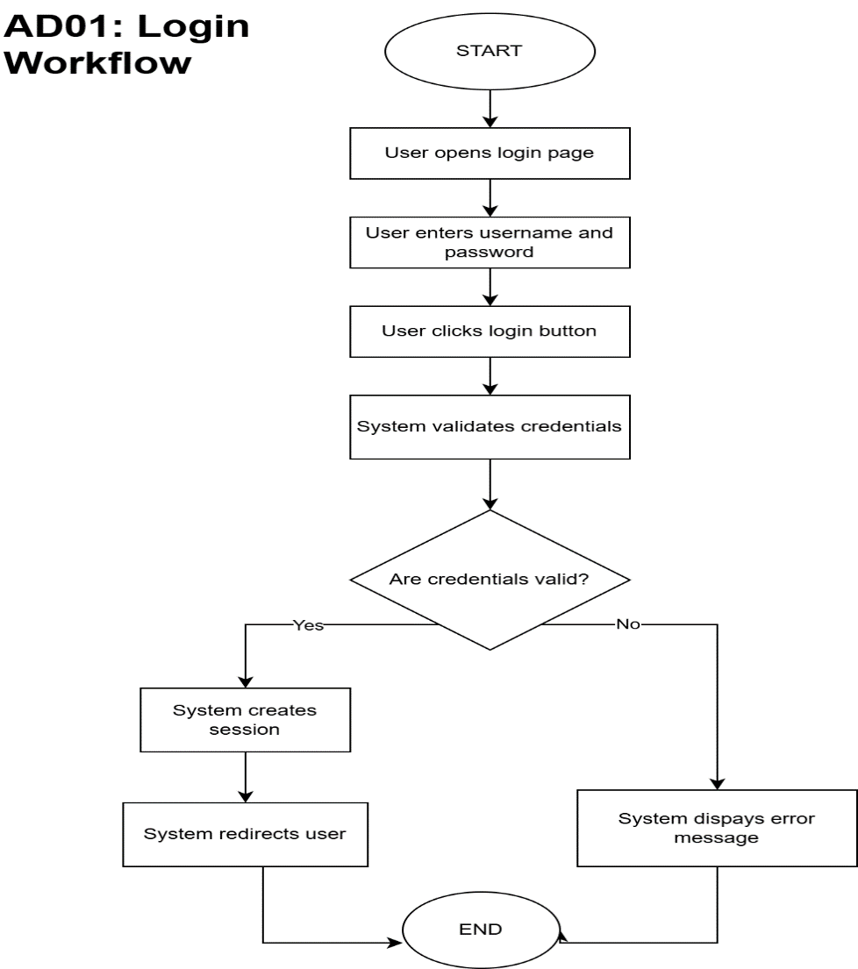

AD02: Search workflow
- Start condition: User is on a page with access to the search field
- Main flow steps:
  - User enters a keyword in the search field
  - User submits the search
  - System searches matching post title / content
  - System displays search results
- Alternate/exception flows:
- No results are found
- Search term matches only tags and not title /content
- System may not return results (known limitation)
- End states:
- Matching results displayed
- No results message displayed

(Attached diagram AD02_SEARCH_WORKFLOW.drawio)

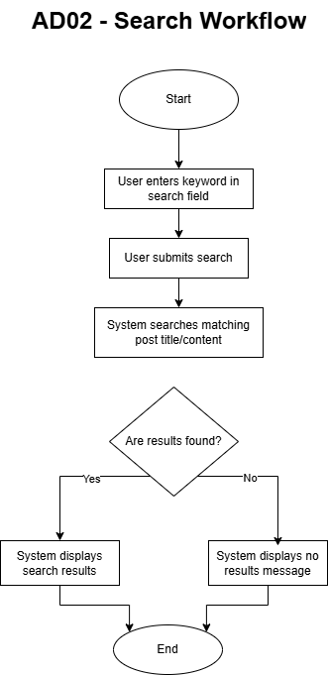

AD03: Comment submission and moderation workflow
- Start condition: User is viewing a post page with a comment form
- Main flow steps:
  - User opens a post
  - System checks whether the user is logged in
  - If the user is logged in, the user can enter and submit a comment
  - User enters a comment in the comment form
  - User submits the comment
  - System validates the comment content
  - System stores the comment with pending approval status
  - Admin or Author opens the comments management page
  - System displays the list of comments
  - Admin or Author selects a pending comment
  - System checks user permissions
  - If the user has permission, the comment is approved
  - System updates the comment status
  - Approved comments become visible on the related post page
- Alternate/exception flows:
- User is not logged in (System prompts the user to log in or redirects to the login page. The user must authenticate before submitting a comment)
- User submits an empty comment
- System displays an error message
- No pending comments exist for moderation
- User attempts moderation without sufficient permissions
- System denies the action
- End states:
- Comment submitted and approved, visible on the post page
- Comment submitted but remains pending
- Action denied due to insufficient permissions
- Comment submission blocked due to validation or access issue
- User is redirected to login before comment submission
(Attached diagram AD03_COMMENT_WORKFLOW.drawio)

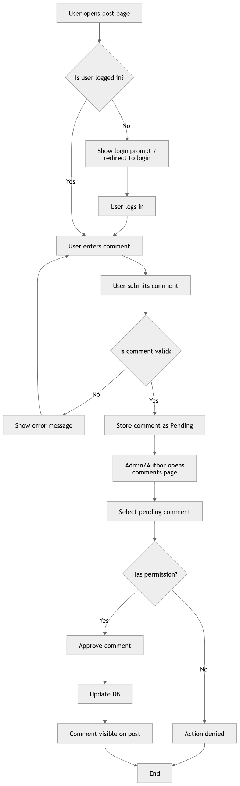
AD04: User management / create, edit, assign roles or deactivate accounts
- Start condition: Admin is authenticated and on the WordPress Admin Dashboard
- Main flow steps:
  - Admin navigates to Dashboard 🡪 Users
  - Admin clicks “Add New” to create a new user
  - Admin fills in username, email, first name, last name and assigns a role (Subscriber, Author, Admin)
  - Admin sets an initial password
  - Admin clicks “Add new user”
  - WordPress saves the user record to the database
  - Admin can also edit an existing user’s role or profile via “Edit”
  - Admin can delete a user account (with option to reassign content)

- Alternate/exception flows:
- Duplicate username or email: WordPress blocks creation and displays validation error
- Non-Admin attempts to access Users menu: access is denied, menu is not visible
- Admin deletes own account WordPress prevents self-deletion

- End states:
- End State A (User created): New user account is active and can log in
- End State B (Role updated): Existing user’s permissions are changed immediately
- End State C (User deleted): Account is removed and content is reassigned or deleted

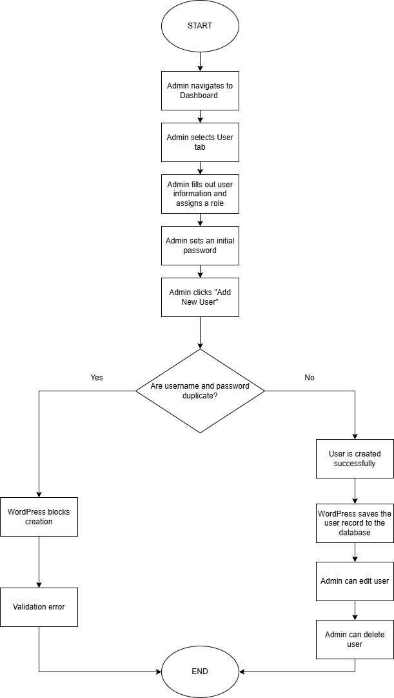
(Attached diagram AD04_user_management_workflow.drawio)

AD05: Create / Edit / Publish Post
- Start condition: Author or Admin is authenticated and on the WordPress Admin Dashboard
- Main flow steps:
  - User opens a post in the Editor (Dashboard🡪Posts🡪Add new post)
  - User enters the post title (mandatory)
  - User enters the post body content (text, board game description, review)
  - User uploads or selects featured images
  - User assigns the post to one or more categories (e.g. Card games, Strategy)
  - User clicks “Publish” to make the post live or “Save draft” to store it unpublished
  - WordPress saves the post to the database and (if published) makes it visible on the public blog
- Alternate/exception flows:
- Network error during save: Post is not saved and user is shown an error. Draft may be recovered via autosave
- Admin edits any post: Full access is granted regardless of post author

- End states:
- End State A (Published): Post is live and visible on the blog and category pages
- End State B (Draft saved): Post is stored but not publicly available
- End State C (Error): Post save fails and user remains on the editor with an error message

(Attached diagram AD05_post_creation_workflow.drawio)

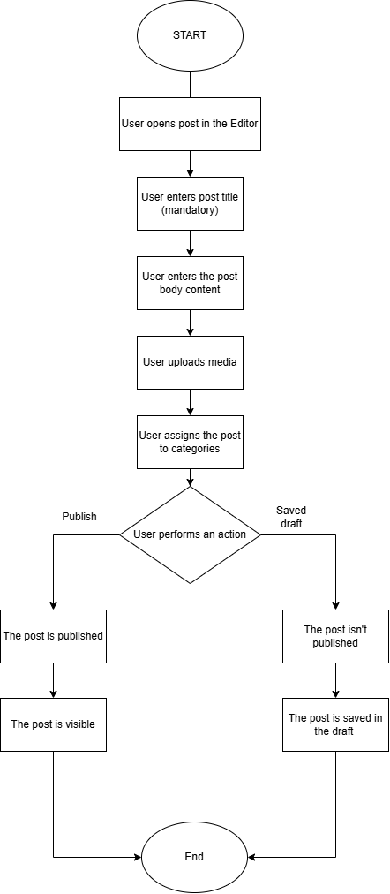

5. Sequence Diagrams
SD01: Login workflow
- Participants: Browser, Wordpress Application, Database
- Messages/steps:
  - Browser sends login request with username and password
  - Wordpress application validates credentials
  - Wordpress application queries the database for user data
  - Database returns matching user record or failure
  - Wordpress application creates session if valid
  - Browser receives redirect or error message
- Validation points:
- Credentials are validated correctly
- Successful login creates a valid session
- Invalid credentials return an error message
(Attached diagram SD01_LOGIN.drawio)
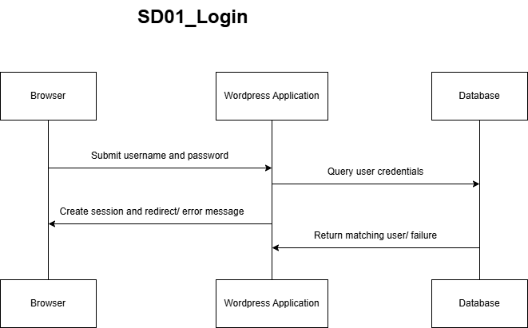

SD02: Search workflow
- Participants: Browser, Wordpress Application, Database
- Messages/steps:
  - User enters a keyword in the search field
  - Browser sends search request
  - Wordpress application queries the database for matching content
  - Database returns matching posts based on title / content
  - Wordpress application returns results to browser
- Validation points:
- Results are based on post title/content only
- Tag-based results are not returned (theme limitation)
- No results message is displayed when applicable
- Keyword retained on no-results scenario
(Attached diagram SD02_SEARCH.drawio )
SD03: Comment submission and moderation
- Participants: User, Browser, Wordpress Application, Database, Admin/Author
- Messages/steps:
  - User opens a post
  - Browser requests the post page from the WordPress application
  - WordPress application returns the post page
  - User attempts to submit a comment
  - WordPress application checks whether the user is authenticated
  - If the user is not logged in, the system displays a login prompt or redirects to the login page
  - User logs in successfully
  - User submits the comment
  - WordPress application validates comment content
  - WordPress application stores the comment in the database with pending status
  - Admin opens comments page
  - Application retrieves pending comments from database
  - System checks permissions before approval
  - Admin or Author approves comment if permitted
  - Application updates comment status in database
  - Approved comment becomes visible after moderation

- Validation points:
- Users must be authenticated before submitting comments
- Unauthenticated users are prompt to log in before continuing
- Comment is saved with pending status
- Comment is not visible before approval
- Only authorized users can approve comments
- Approved comment becomes visible after moderation
(Attached diagram SD03_COMMENT SUBMISSION_MODERATION.drawio)
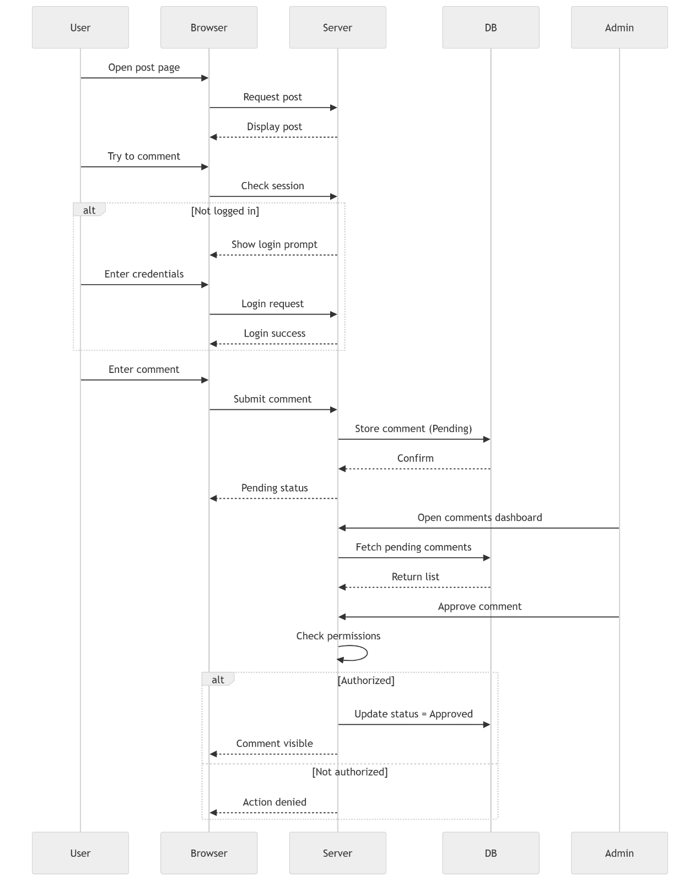

SD04: User management workflow
- Participants: Browser, WordPress Application, Admin, Database
- Messages/steps:
- Admin requests the Users page
- WordPress validates role and retrieves user list from the database, then displays it
- Admin selects “Add New”
- WordPress renders the user creation form
- Admin submits new user data
- WordPress validates input, checks for duplicates, saves the user in the database, and returns confirmation with updated list
- Admin selects an existing user to edit
- WordPress fetches user data and displays the edit form
- Admin updates user details
- WordPress validates and updates the database, then confirms the changes
- Admin initiates user deletion
- WordPress validates the action, processes deletion or reassignment, updates the database, and refreshes the user list

- Validation points:
- Only Admin can access and manage users
- Username and email must be unique
- New users are created successfully and can log in
- Role changes are applied immediately
- Admin cannot delete own account
- Deleted user content is reassigned or removed properly
(Attached diagram SD04_user_management_workflow.drawio)
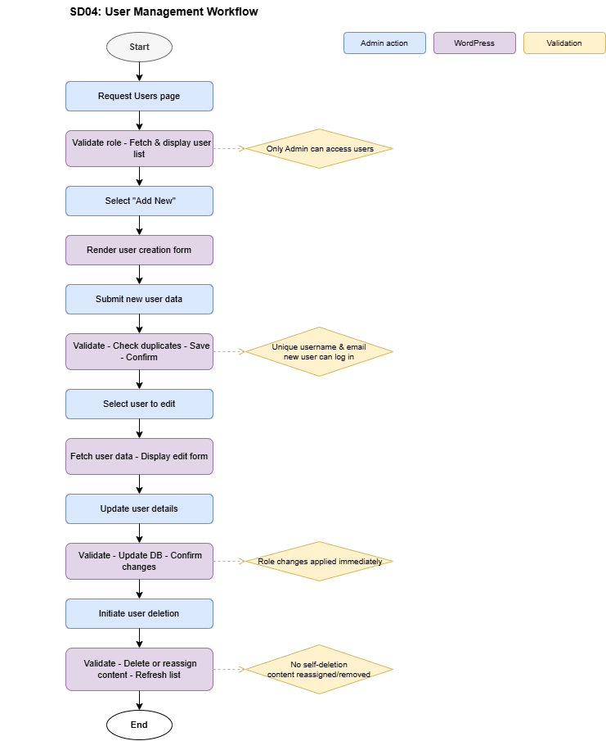
SD05: Create and Publish post workflow
- Participants: Browser, WordPress application, Database, Admin/Author
- Messages/steps:
- User opens the post editor and creates a new post by entering title, content, featured image categories and tags
- The browser sends a save or published request to WordPress
- WordPress validates the input and stores the post in the database as a draft or published item
- The database returns a success or failure response, and WordPress shows a confirmation or error message
- If published, the post becomes visible on the front-end
Validation points:
- Title is mandatory for publishing
- Only authorized users can create/edit posts
- Post is saved correctly as draft or published
- Errors (e.g. network issues) prevent saving and show message
- Published posts are visible on the blog, drafts are not

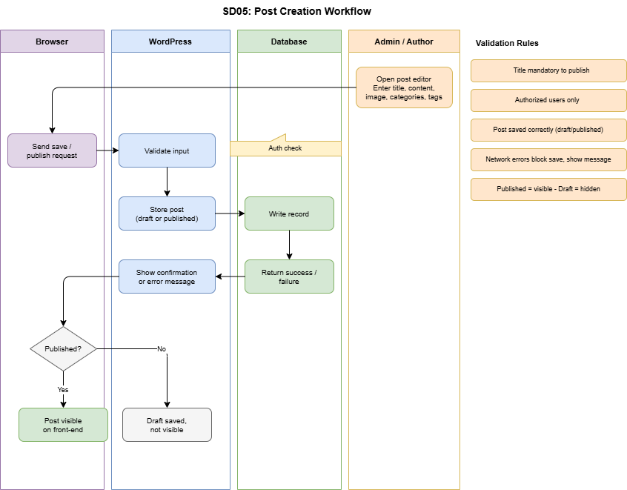

6. Business Rules
- BR01: Authentication
Login requires valid username and password.

- BR02: Comment Submission
Only logged-in users can submit comments.
- BR03: Comment Moderation
Comments are stored with pending status and require approval.
- BR04: Search Behavior
Search returns results based on post title/content only.
Tag-based search is not supported (known limitation).
- BR05: Role-Based Access Control
Permissions are enforced based on user role (Admin, Author, Subscriber).
- BR06: Moderation Permissions
Authors can moderate comments only on posts they own.
Admins can moderate all comments.
- BR07: User Management
Only Admin can create, edit, assign roles, or delete users.
- BR08: Post Management
Only authorized users (Author/Admin) can create and publish posts.
- BR09: Data Integrity
All submitted data (comments, posts, users) must be stored correctly in the database.
- BR10: User Feedback
System should provide feedback for:
    - login errors
    - empty inputs
    - no search results
(Some limitations may apply due to theme behavior)

